**Project Design Phase-II**

**Technology Stack (Architecture & Stack)**

|  |  |
| --- | --- |
| Date | 05 October 2022 |
| Team ID | PNT2022TMID41909 |
| Project Name | Signs with Smart Connectivity for Better Road Safety |
| Maximum Marks | 4 Marks |

**Technical Architecture:** 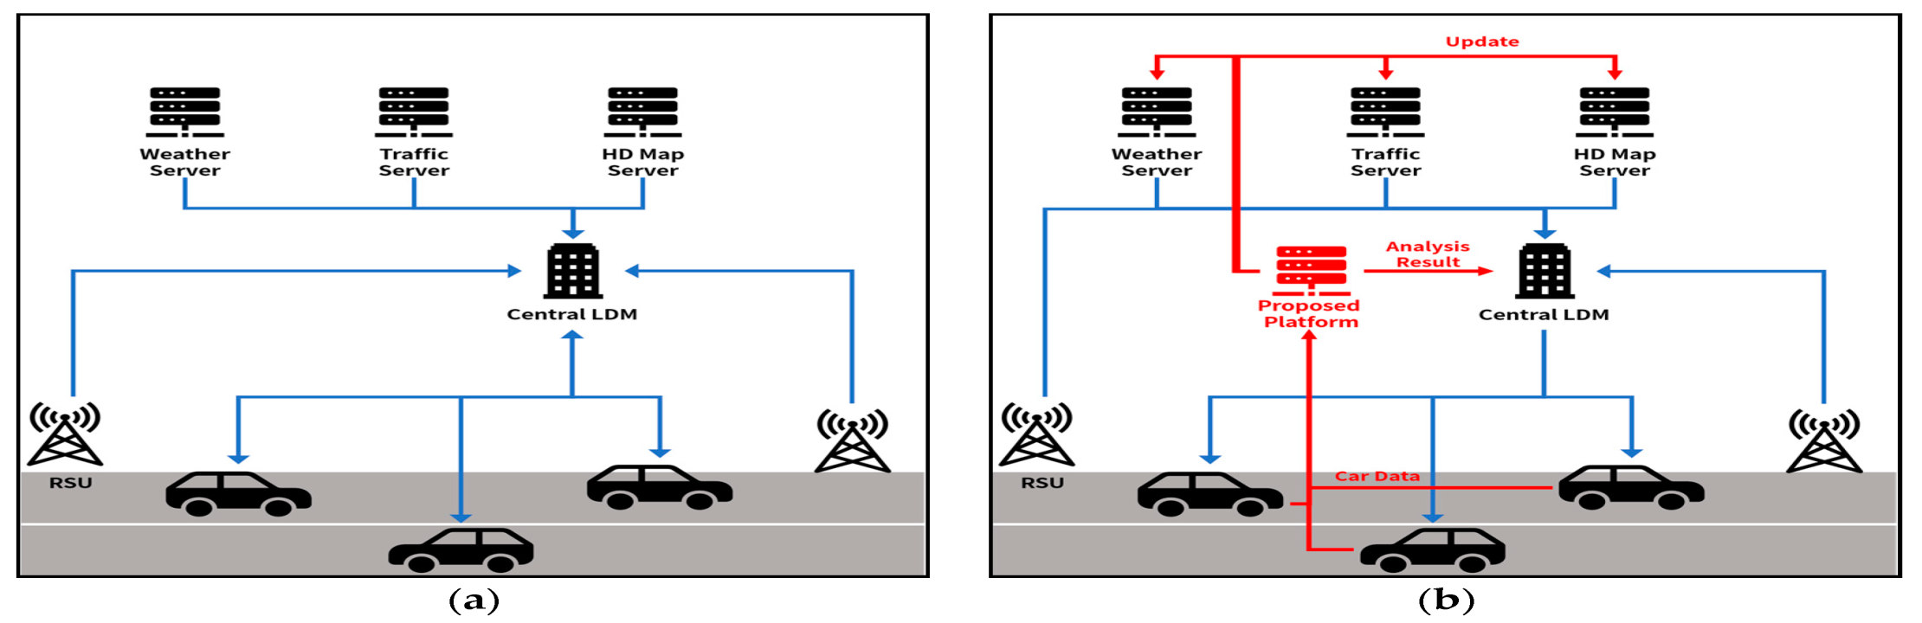

**Guide lines:**

* To replace static sign boards into smart connected sign board
* These smart connected sign boards gather the speed limitations from the weather app using weather API and update automatically
* Based on the weather changes the speed may increase or decrease
* Sign board s in the vicinity of the hospitals, schools ,restarunts etc have signs displayed accordingly
* Different modes of operation can be selected with the help of buttons

|  |  |  |  |
| --- | --- | --- | --- |
| **S.NO** | **Component** | **Description** | **Technology** |
| **1** | User interface | How user interacts with application e.g Web UI, mobile App, chatbot etc. | HTML, CSS, JavaScript / Angular Js/React Js etc. |
| **2** | Application logic-1 | Logic for a process in the application | Java / python |
| **3** | Application logic-2 | Logic for a process in the application | IBM Watson STT service |
| **4** | Application logic-3 | Logic for the process in the application | IBM Watson Assistent |
| **5** | Database | Data Type, Configuration etc. | MySQL , NoSQL, etc. |
| **6** | Cloud Database | Database Service on cloud | IBM DB2,IBM Cloudant etc. |
| **7** | File Storage | File storage requirements | IBM Block Storage or other storage service or local filesystem |
| **8** | External API-1 | Purpose of external API used in the application | IBM weather API,etc |

**Components and Technologies:**

**Application Characteristics:**

|  |  |  |  |
| --- | --- | --- | --- |
| **S.NO** | **Characteristics** | **Description** | **Technology** |
| **1** | Security Implementations | Strong security system that anyone without login credenitals and hackers are not allowed to enter the network | Cyber,  Firewall,fire base  Resiliency statergy |
| **2** | Scalable Architecture | Easy to expand the operation range by increasing the band width of the network | IOT internet |
| **3** | Availability | Available any time and every where as long as the user is signed into the network | IBM cloud |
| **4** | Perfomance | Support a large number of users to access the technology simultaneously | IBM cloud |